2022 Local Plan Modifications

1a. Provide information regarding service strategies implemented both in the physical AJCs, as well as virtually, to include a description of:
The East Tennessee Local Workforce Development Board, as a strategic leader, boasts a strong partnership with employers, education providers, and economic development agencies. This strong partnership has provided the venue for East’s implementation and transition to a technology focused operation. The ETLWDB aligns workforce development, education, and economic development.

1b. How the one-stop system is implementing and transitioning to more integrated, technology-focused operations to improve outreach to jobseekers and employers, provide intake, and enhance case management for programs carried out under all partners included in the workforce
East has embraced the following technology: Menti, Doodle, DocuSign, Premier Virtual, Engage By Cell, WebEx, Microsoft Teams, Zoom, and piloted the deployment of the Virtual AJC Scheduling component. The implementation of this technology has improved outreach to job seekers and employers, enhanced common intake across all AJC partners, and augmented the ability and functionality of case management, especially during the heart of the pandemic. East’s federal performance metrics and the state’s Key Performance Indicators during the pandemic, and continuing, reflect little or no change in pre and post enrollment targets and performance.

1c. Provide a description of the initiatives the LWDB (including all partners) are implementing or will be implementing to ensure accessibility to programmatic services.
ETLWDA utilizes the scheduling feature, Appointment Scheduling, of the Virtual AJC as a common point of entry for the workforce system. East’s deployment of DocuSign, available to all partners, ensures accessibility to programmatic services. East embraced remote access to services during the height of the pandemic and continues this model to ensure programmatic services are delivered seamlessly throughout the area. American Job Centers are strategically located throughout the Area and are accessible by differently abled individuals. The ETLWDA utilizes VOS to accommodate customer intake, case management, and accountability reporting among partners. Jobs4TN/VOS provides an integrated electronic application that gathers relevant information to determine eligibility for Titles I, II, and III of WIOA (SNAP, TAA/TRA, Apprenticeship) while sharing common information. This electronic application serves as the repository for all related activities and includes electronic case notes that should document a participant's progress. The entirety of the application presents a total picture regarding an individual's interaction with the workforce system. East’s usage of DocuSign for electronic signature has strengthened the Area’s ability to deliver services. Recognizing that many of the rural/remote areas of East continue to struggle with access to technology, ETLWDA has increased its span of reach in establishing access points, with broadband access, to many of the rural counties. East plans to continue its expansion of access points throughout the life cycle of this plan.

1d. How will technology continue to improve the connection to partners across the workforce system? Include the advances made during, as well as those to continue post-COVID.
East made great strides during the apex of the pandemic with its deployment of technology. East plans to continue the momentum gained. DocuSign, especially, removed the barrier requiring individuals to be physically present for completion of “signature required” paperwork. DocuSign’s “tracking” feature improved East’s connection to partners/clients/business community. Premier Virtual provided the necessary venue to continue improvement in our connection with the business community and their personnel requirements. Engage By Cell, as an outreach tool, was and is utilized to announce job fairs; AJC monthly calendar/special events, Mobile AJC schedule, notices for public comment, polling with Board members, employers, AJC partners, and key stakeholders in the ETLWDA. East firmly believes our unique blending of various technologies sustained our enrollment/performance numbers throughout COVID. East continuously seeks innovative technology to improve connections to partners across the workforce system.

2a. Describe how the Local Board will support the strategy identified in the TN Combined State Plan and work with entities carrying out core programs, including a description of:
The TN Combined State Plan through its interpretation and implementation of findings from local needs assessments formulated by the Local Education Authorities within the sixteen County area guides the actions of the ETLWDA. A vast array of community-based entities involved in quarterly partner meetings, support and supplement the ETLWDA service delivery system. These Community-based organizations include but are not limited to Goodwill Industries, Clinch Powell, YouthBuild, Knoxville Area Urban League, and the Knoxville-Knox County Community Action Committee.

2b. Expanding access to employment, training, education, and supportive services for eligible individuals, particularly eligible individuals with barriers to employment, including individuals with disabilities
The OSO regularly convenes meetings with partners and other stakeholders that links community workforce development service providers to each other and to the local workforce service delivery network. The development of stakeholder groups is integral in framing strategic solutions to serve targeted populations, especially those with barriers to employment including individuals with disabilities. East has a robust partnership with stakeholder groups comprised of advocates for re-entry, immigrant, and refugee, homeless, disability and youth communities which contributes to is expanding reach. East’s extensive list of access points expands the access and availability of employment, training, education, and supportive services for eligible individuals. East continues to evaluate its network of access points and its placement of brick-and-mortar AJCs throughout the 16-county area to ensure the most coverage and awareness of services available to eligible individuals, particularly those with barriers to employment. East places heavy emphasis on the utilization of the Mobile AJC to provide on demand access in remote areas not covered by an access point or brick-and-mortar AJC.

2c. Facilitating the development of career pathways and co-enrollment, as appropriate, in core programs and improving access to activities leading to a recognized post-secondary credential (including a credential that is an industry-recognized certificate or certification, portable, and stackable).
East facilitates monthly meetings between area TBOR/THEC entities within the service delivery area. These monthly meetings in connection with Local Education Authority evaluations have resulted in pre-ETS initiatives in several counties (with availability to all) and a specialized AJC at the CTE campus of Union County. The area WIOA Title II Adult Education contractor provides basic skills instruction leading to the successful completion of the equivalency diploma with a focus on co-enrollment, as appropriate, with Title I, in conjunction with CTE, for the successful development of career pathways leading to industry-recognized credentials. East’s expansive utilization of Coursera and its skill development/skillsets expands the opportunities for development/enhancement of career pathways with industry recognized (Google, IBM, Microsoft, etc.,) partners.

3a. Describe the employer engagement strategy to better connect business with well-trained and qualified applicants.
To ensure that AJC customers remain competitive in the labor market, it is vital that ETLWDA and our partners understand the needs of the local area’s businesses and tailor the workforce system to address those needs. ETLWDA encourages businesses at every step in their lifecycle. When a business is growing and hiring, we offer hiring assistance, funds for training new employees, customized recruitment, job fairs, qualified candidate referrals, resume screening, and business process improvements. On the other hand, when a business is downsizing, we attempt support to avert layoffs and to help laid-off workers quickly find new positions in similar sectors. Utilizing the newest materials provided by the state (Quick Guide for Hiring Talent and the AJC Flyers Guide), East will ramp up outreach efforts by distributing these materials to community partners and by participating in events focused on priority populations within the 16-county area. East will continue its use of technology, the creation of a system shared, available to all partners and their business engagement staff, SharePoint document, to further its penetration into the business community and target employers specific to our priority populations.

3b. Provide a description of how the LWDB will implement initiatives such as apprenticeships, incumbent worker training programs, on-the-job training programs, customized training programs, industry and sector strategies, career pathways initiatives.
The One-Stop Operator facilitates employer engagement of all partners through an Integrated Business Service Team approach. While the OSO schedules monthly Business Service meetings to provide a structured environment for sharing information, they also provide notice of employer related information such as new job orders, upcoming job fairs, and on-the-job training opportunities throughout the AJC. While many employers seek out services and are greeted by knowledgeable staff via the phone or in person, many do not. With the multitude of technology options available today, we are reaching many employers through social media and websites, including the TN Department of Labor - Employer Service portal. Business Service staff from the local areas are meeting quarterly and working together to assure that employers throughout the region are familiar with the AJC and its services. Armed with the latest Employer Engagement toolkit, made available by the state, the BST provides information and engages the employer community regarding Jobs4TN, OJTs, IWTs, apprenticeships, and job fairs. Relevant labor market information including industry competition/commuting patterns, special projects such as jail programs and sector strategies comprise the information readily available to the BST.

3c. Include the utilization of effective business intermediaries, and other business services and strategies designed to meet the needs of employers in the corresponding region in support of the business service strategy.
Strategically focused collaboration between existing partners (Title I, II, III, IV, SNAP E&T, TANF, Chambers of Commerce, State and Local ECD) will improve the overall reach of the AJC system. Understanding the strategy of transferrable skills, ensuring individuals are recognized by employers as qualified/trained are important aspects to a “Work First” strategy. Inspired by tracking documents used by JVSG, East will implement a shared document to track employer/business engagement across all partners of the AJC system, independent of permission levels within VOS. All partners will have access to the SharePoint document and become members of the Business Service Team, focus will be uniform and unduplicated within the system, and a point person or team will conduct actual contact with the employer. Existing partnerships with Board Members, SCSEP and Work Experience employers, ECD, and Career Technical Education partners will be strengthened and used as a launch pad for furthering business engagement/penetration.

3d. How will you measure the effectiveness of the strategy outside of mandated business performance measures? Include information to support the increase of Labor Force Participation Rates.
The ETLWDB has been very vocal on its understanding of the Labor Force Participation Rate. Several of the business community representatives on the Board related common problems regarding the available applicant pool and the apathy demonstrated by many of the individuals that were interviewed. These discussions were an impetus to East’s launch of “Work First”. “Work First” is a bold stride towards increasing the Labor Force Participation Rate in East. Coupled with our focus on Justice Involved, Vocational Rehabilitation, and others with significant barriers to employment, East should realize a significant improvement in its Labor Force Participation Rates. East will utilize the reporting function within Jobs4TN as a basis for performance measurement. East will focus on “Outcomes” within the business community: measured by employer feedback. The SharePoint document will track these “Outcomes” within the business community, allow for unduplicated focused contact, tracking, and reporting.

4a. In relation to the Governor's key priorities, provide an overview of current and/or new strategies being implemented by your Local Workforce Development Board (LWDB) to ensure workforce partners collaborate on:
All partners in the workforce delivery system understand the current shortage of qualified workers, embraced the ETLWDB’s view/understanding of the need for re-evaluation of current practices, and have endorsed “Work First” as a system strategy. The ETLWDB is revising its Support Service policy to promote the Work First initiative, offering support to persons who are entering the workforce, assisting participants with supportive services up to 60 days while in the “startup” phase of new employment.

4b. Implementation of programs to best serve the rural communities, including economically distressed and at-risk counties; 2) criminal justice reform; 3) vocational and workforce development; and 4) other individuals in priority populations
East has long recognized the vulnerability of our rural communities and the individuals represented, especially those living in our two distressed and six at-risk counties. East continues working to improve services and reach priority populations. East, in connection with Union County LEA purchased Transfer VR for training/development/career exploration in this at-risk county. East, in connection with Cocke County LEA and Vocational Rehabilitation, funded Paid Work Experience for CTE/Pre-ETS individuals in this distressed county. East continues to focus additional resources in funding Paid Work Experience in Campbell and Morgan Counties, two additional at-risk counties. East has focused its incumbent worker training resources in at-risk and distressed counties. East, in connection with its educational partner, TCAT Oneida/Huntsville funded a specialized welding training program for dislocated workers in Scott County to meet our business partner’s, Great Dane, need in this distressed county.
East has a long and recognized history of working within the criminal justice reform arena. East continues its work with the Day Reporting Center in Knoxville and its work with the Morgan County Correctional Complex. East, in response to the notice of award for Justice Involved Individuals Grant, requested funding to assist recently released individuals to train for and obtain a class A Commercial Driver License to begin work with our business partner TLD as heavy tractor trailer drivers.

5a. Describe any partnerships, new collaborations, or innovative practices you would like to share that include connections with non-profit or other community organizations.
Recognizing the “Great Resignation” of 2021 changed the face of workforce and the resulting outcry from the employer community regarding a qualified labor force, the East TN Local Workforce Development Area is piloting a “Work-First” initiative to ameliorate the effects of the low supply of workers and increase the labor force participation rate. ETLWDA is committed to providing supportive services to give workforce system customers greater opportunity for success. The BST, comprised of all partners within the AJC system, have sought out partnerships with employer organizations such as the Society of Human Resource Managers, Manufacturing Organizations, Chambers of Commerce, and district offices of the Small Business Administration. East includes in its quarterly partners meeting in excess of 75 community and non-profit organizations. Entities, prior to the meeting, submit updates of activities each organization may be engaged in as well as any new or encouraging practices.

5b. How is the local area leveraging these valuable partnerships?
East leverages its partnerships through exchange of information and a warm referral of clients entering the AJC ensuring those individuals at risk or facing significant barriers to employment, including justice involved and those with disabilities, have a wrap-around, holistic approach, towards meeting not only their immediate needs but a sustainable path toward self-sufficiency.

5c. Has the LWDB considered utilizing fees for services to employers as revenue opportunities to further support WIOA allowable activities? If so, provide details of these opportunities
East offers the NCRC for a nominal fee to employers who want to hire competent employees. Staff will administer the assessment at the worksite. ETLWDB welcomes hearing the best practices from other Workforce Development Areas.

6a. How will your LWDB increase physical and programmatic access for each of the fourteen (14)
significant barriers to employment (SBE) groups as outlined within Workforce Services Policy- Key Performance Indicators Section 1(B)?
East has been recognized by the state as the leader and exhibitor of best practices as it relates to the Key Performance Indicators. East will continue its demonstrated programmatic access for each of the fourteen (14) SBE groups. East continues to expand its community engagement/outreach and its footprint of access points to ensure that East will maintain its position as a leader in meeting the needs of those with significant barriers to employment. The East Tennessee Local Workforce Development Area’s strong partnership with the business community, AJC partners, community, non-profits, and faith-based organizations has allowed the East Area to excel. The system cannot effectively serve individuals impacted by barriers to employment from within silos. An effective system must utilize every resource available with the common goal of assisting individuals in overcoming their barriers.

6b. Utilizing the Key Performance Indicator (KPI) form, provide the name of the lead organization (community-based organization, nonprofit, a state agency, etc.), a brief narrative strategy, a list of primary supportive services catered to the SBE's specific needs, and the monitoring methodology/frequency for each SBE group.
Workforce Services Policy - KPIs

Significant Barriers to Employment (SBE) group | Lead Organization | Narrative Strategy | Primary supportive services  catered to the SBE’s specific needs | Monitoring Methodology/Frequency
Displaced Homemakers | Core Partners | See Paragraph 1 | See Paragraph 2 | Monthly and Quarterly
Low-income individuals/recipients of income-based public assistance | Core Partners | See Paragraph 1 | See Paragraph 2 | Monthly and Quarterly
Native Americans | Core Partners | See Paragraph 1 | See Paragraph 2 | Monthly and Quarterly
Individuals with mental or physical disabilities, including the recipients of Social Security Disability Insurance | Voc. Rehab. & Core Partners | See Paragraph 1 | See Paragraph 2 | Monthly and Quarterly
Those age 55 and older | SCSEP and Core Partners | See Paragraph 1 | See Paragraph 2 | Monthly and Quarterly
Justice-Involved Individuals | Core Partners | See Paragraph 1 | See Paragraph 2 | Monthly and Quarterly
Individuals experiencing or have experienced homelessness | Core Partners and Referrals | See Paragraph 1 | See Paragraph 2 | Monthly and Quarterly
Youth in or have aged out of the foster care system | Core Partners | See Paragraph 1 | See Paragraph 2 | Monthly and Quarterly
Individuals who are English language learners, individuals who have low levels of literacy, individuals facing substantial cultural barriers | Adult Education & Core Partners | See Paragraph 1 | See Paragraph 2 | Monthly and Quarterly
Eligible Migrant and Seasonal Farmworkers | Core Partners | See Paragraph 1 | See Paragraph 2 | Monthly and Quarterly
Individuals within two years of exhausting lifetime TANF eligibility | Core Partners | See Paragraph 1 | See Paragraph 2 | Monthly and Quarterly
Single parents, including pregnant women | SNAP E & T Core Partners | See Paragraph 1 | See Paragraph 2 | Monthly and Quarterly
Long-term unemployed (unemployed for 27 or more consecutive weeks) | Core Partners | See Paragraph 1 | See Paragraph 2 | Monthly and Quarterly
Other groups as the Governor determines to have barriers to employment | Core Partners | See Paragraph 1 | See Paragraph 2 | Monthly and Quarterly

Paragraph #1
The OSO, through quarterly cross trainings, coordinates the activities of all core partners in the ETLWDA American Job Centers to ensure that services are provided effectively, resulting in referrals between those core partners (Title 1 (Employment & Training), Title II (Adult Education), Title III (job service), and SNAP E&T, Title IV (Vocational Rehabilitation), and Tennessee Assistance for Needy Families). When necessary, staff will make referrals to organizations outside the AJC. ETLWDA conducts a quarterly partner meeting, where community and faith-based organizations share information about services that may benefit individuals experiencing Significant Barriers to Employment.
Paragraph #2
Core partners are aware of the specific supportive services available throughout the American Job Center system. Partners share a common menu of supportive services to meet the needs of individuals experiencing Significant Barriers to Employment such as transportation assistance, childcare, medical, and other support including but not limited to housing (rent and utilities), tools, clothing, and items needed for work.
7 Budget Information. Provide a detailed budget that lists the sources and uses of Tennessee Department of Labor and Workforce Development (TDLWD) pass-through funds and all non-Federal matching funds by completing a provided budget toolkit (424A).

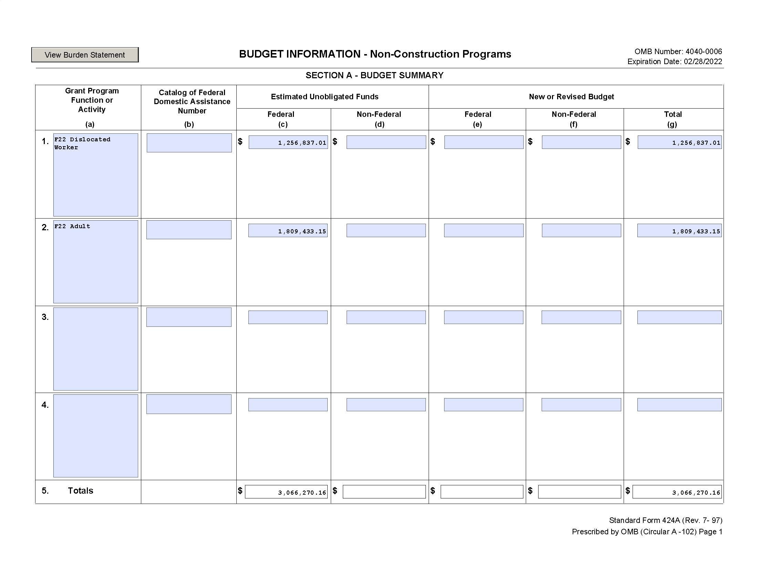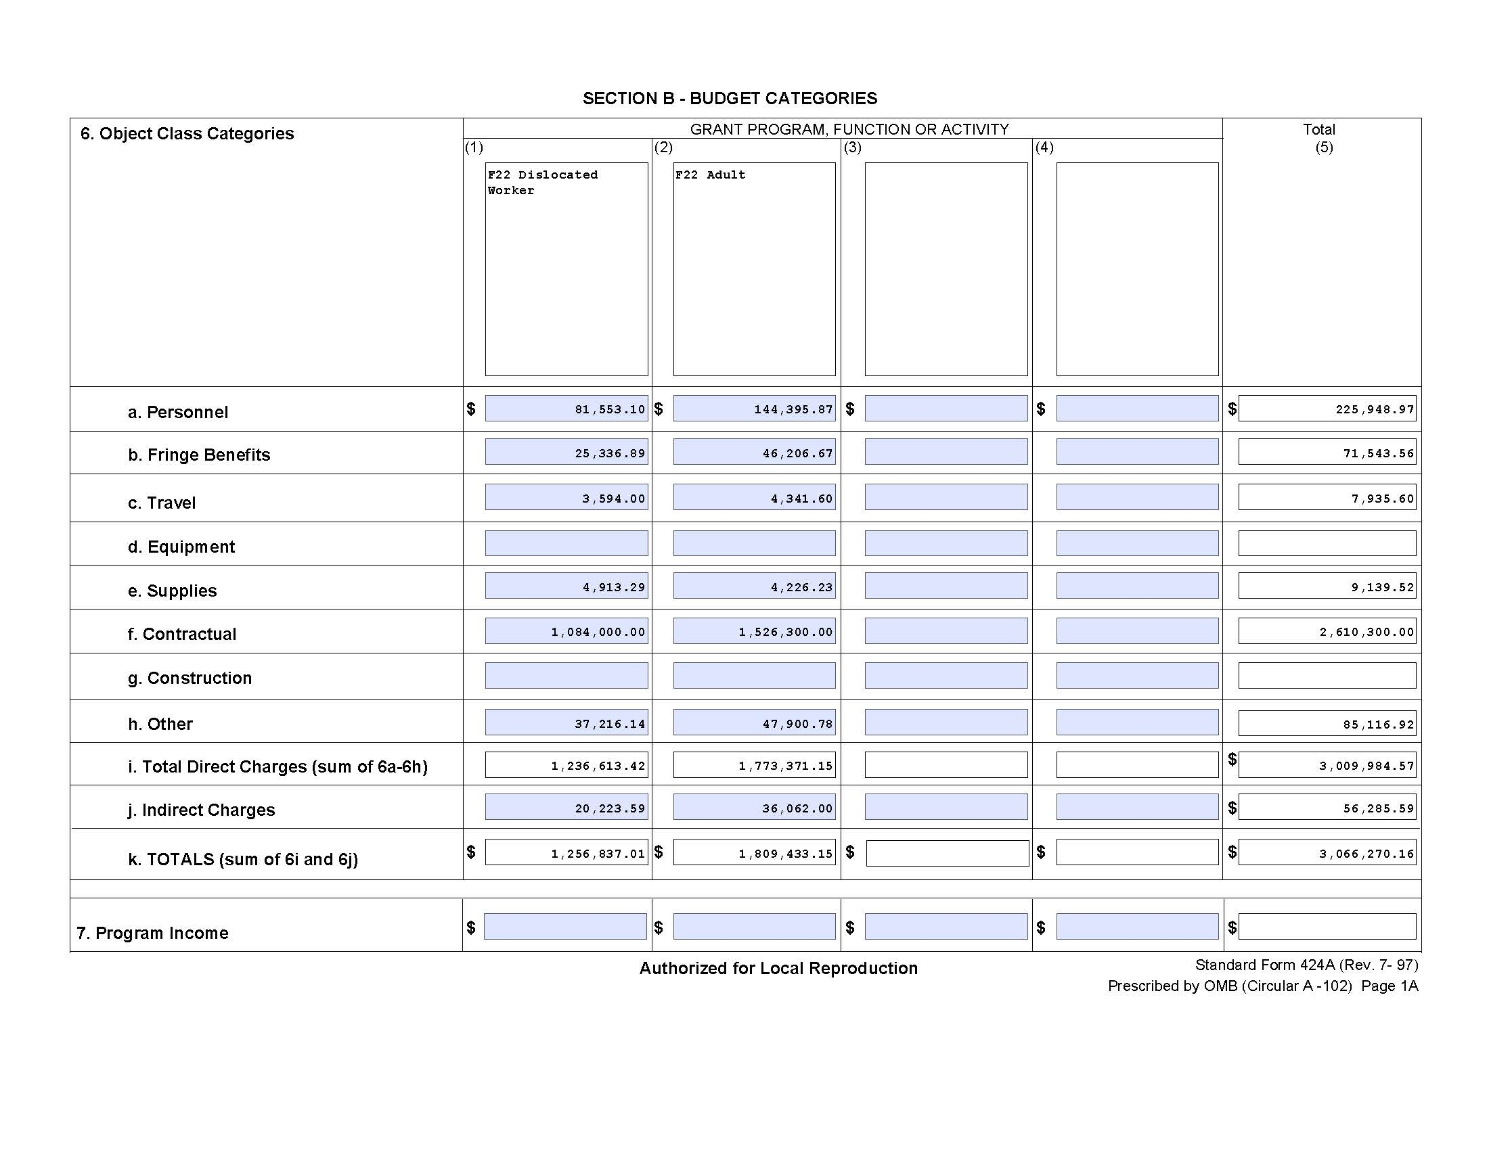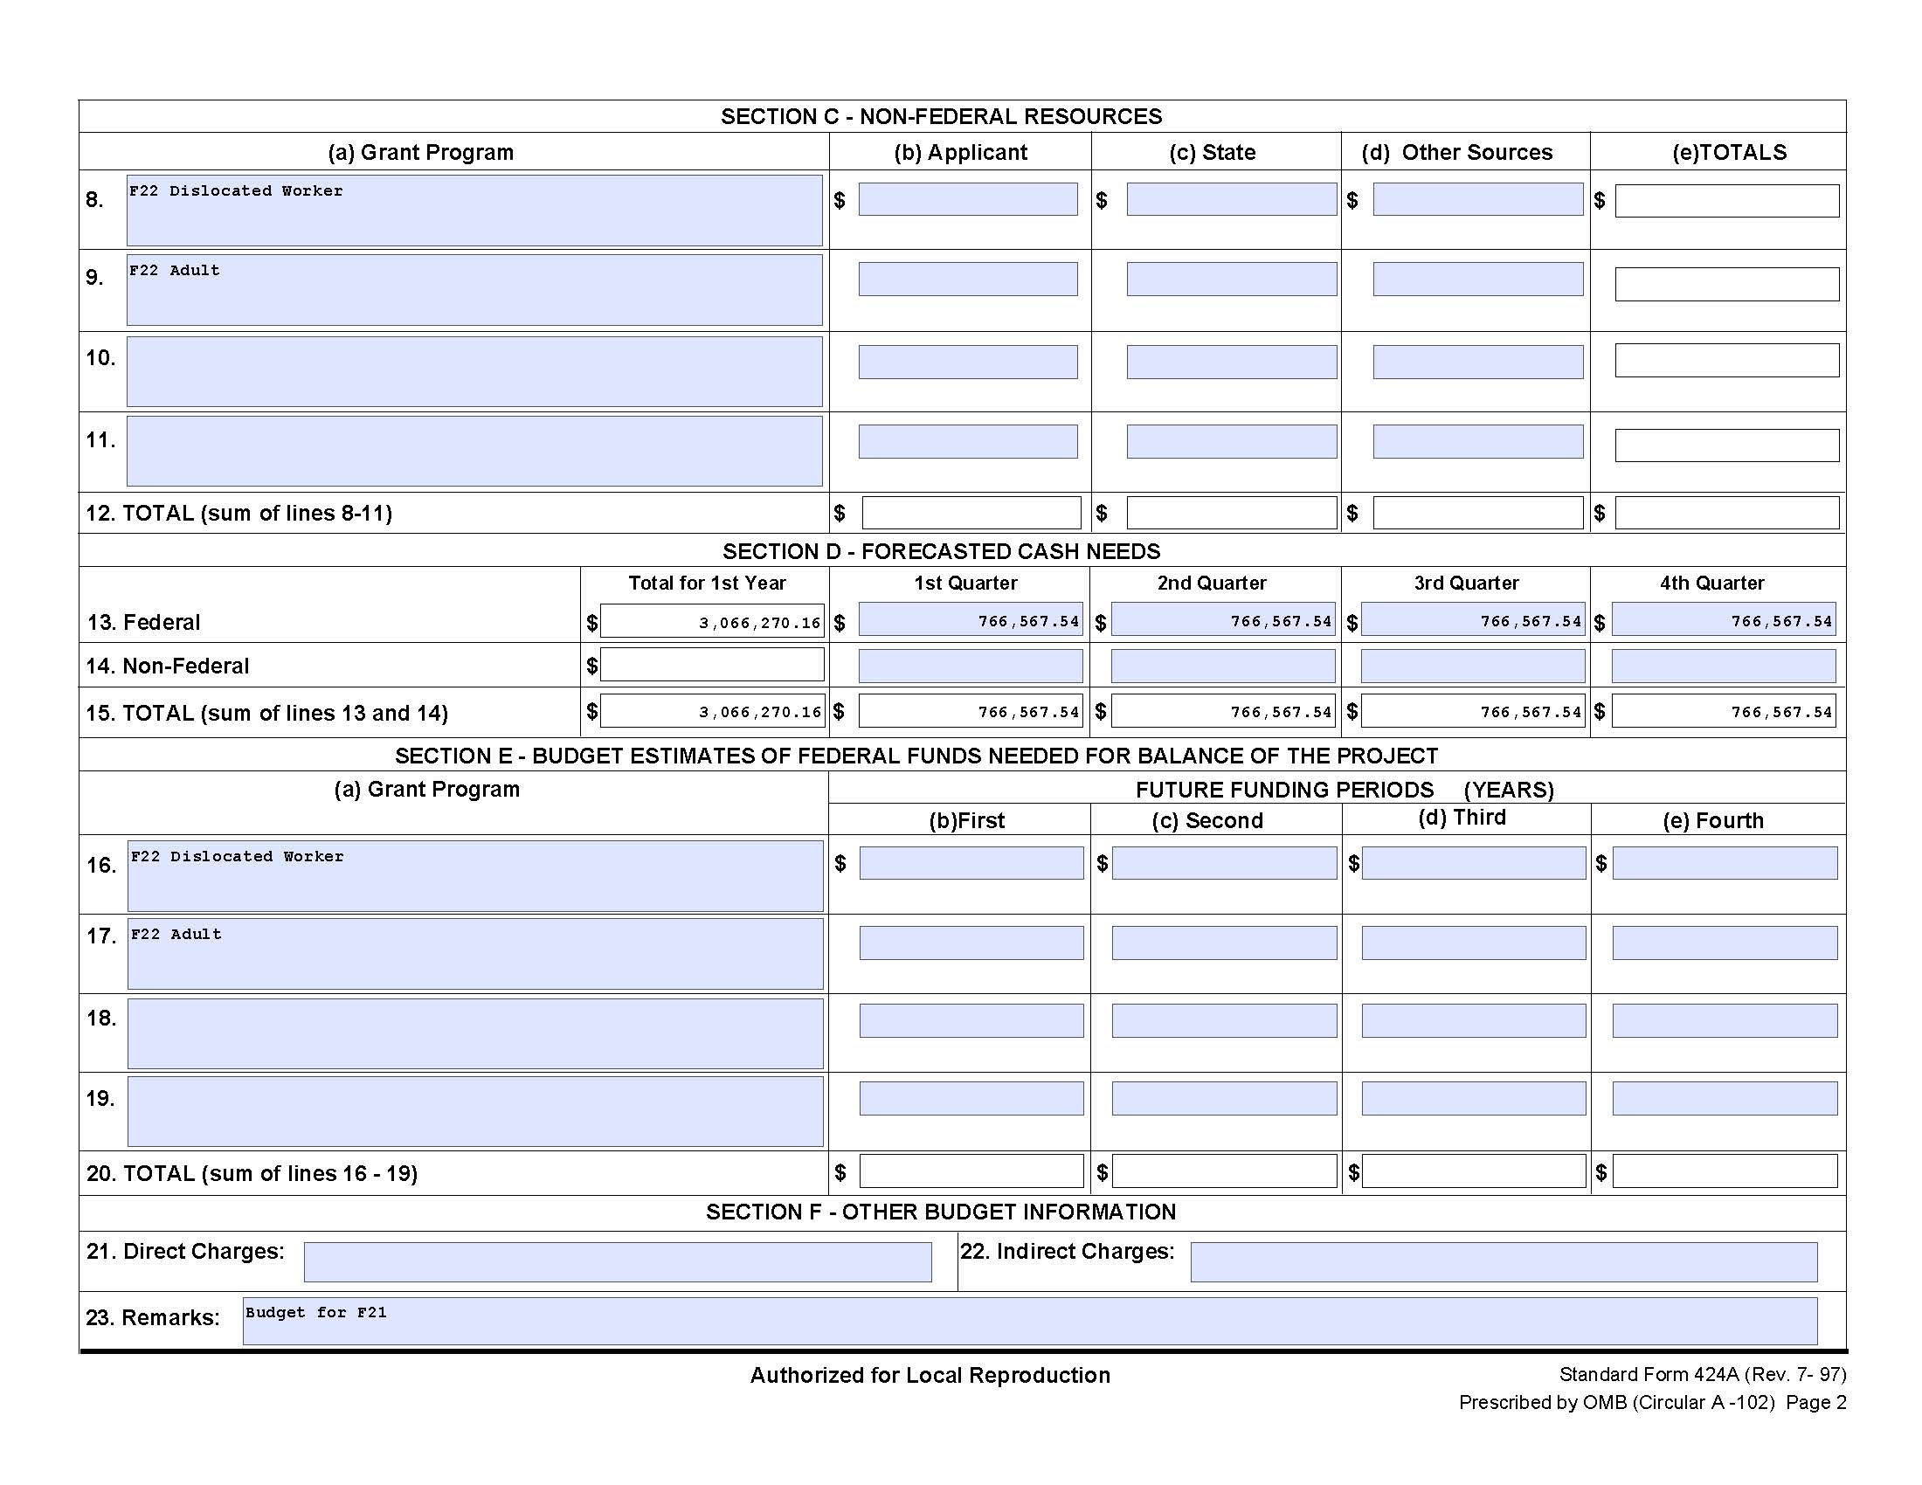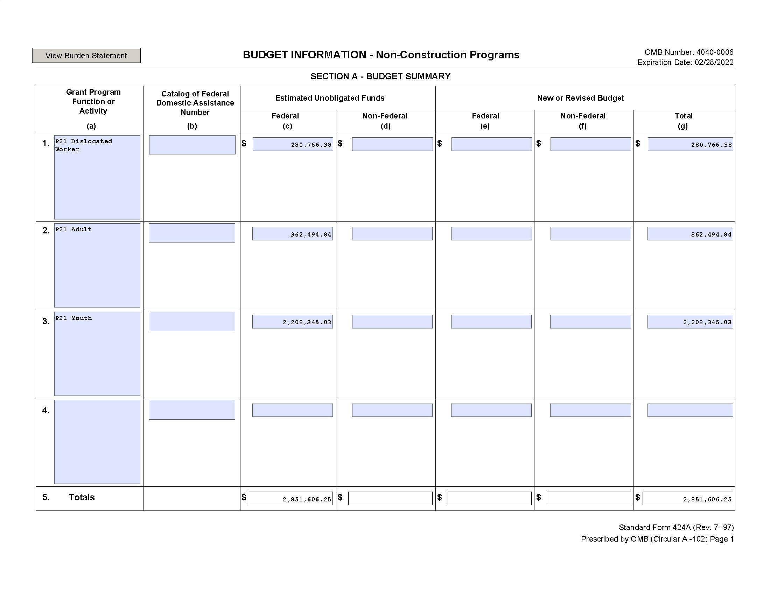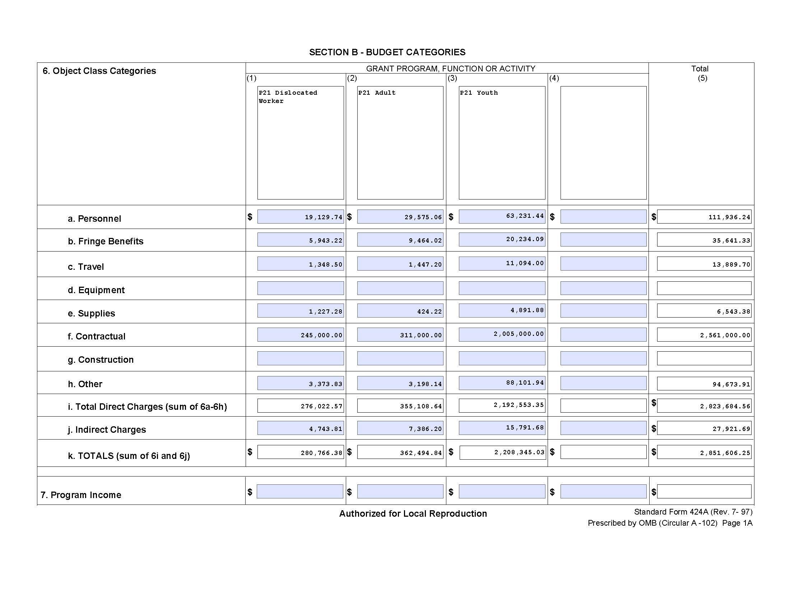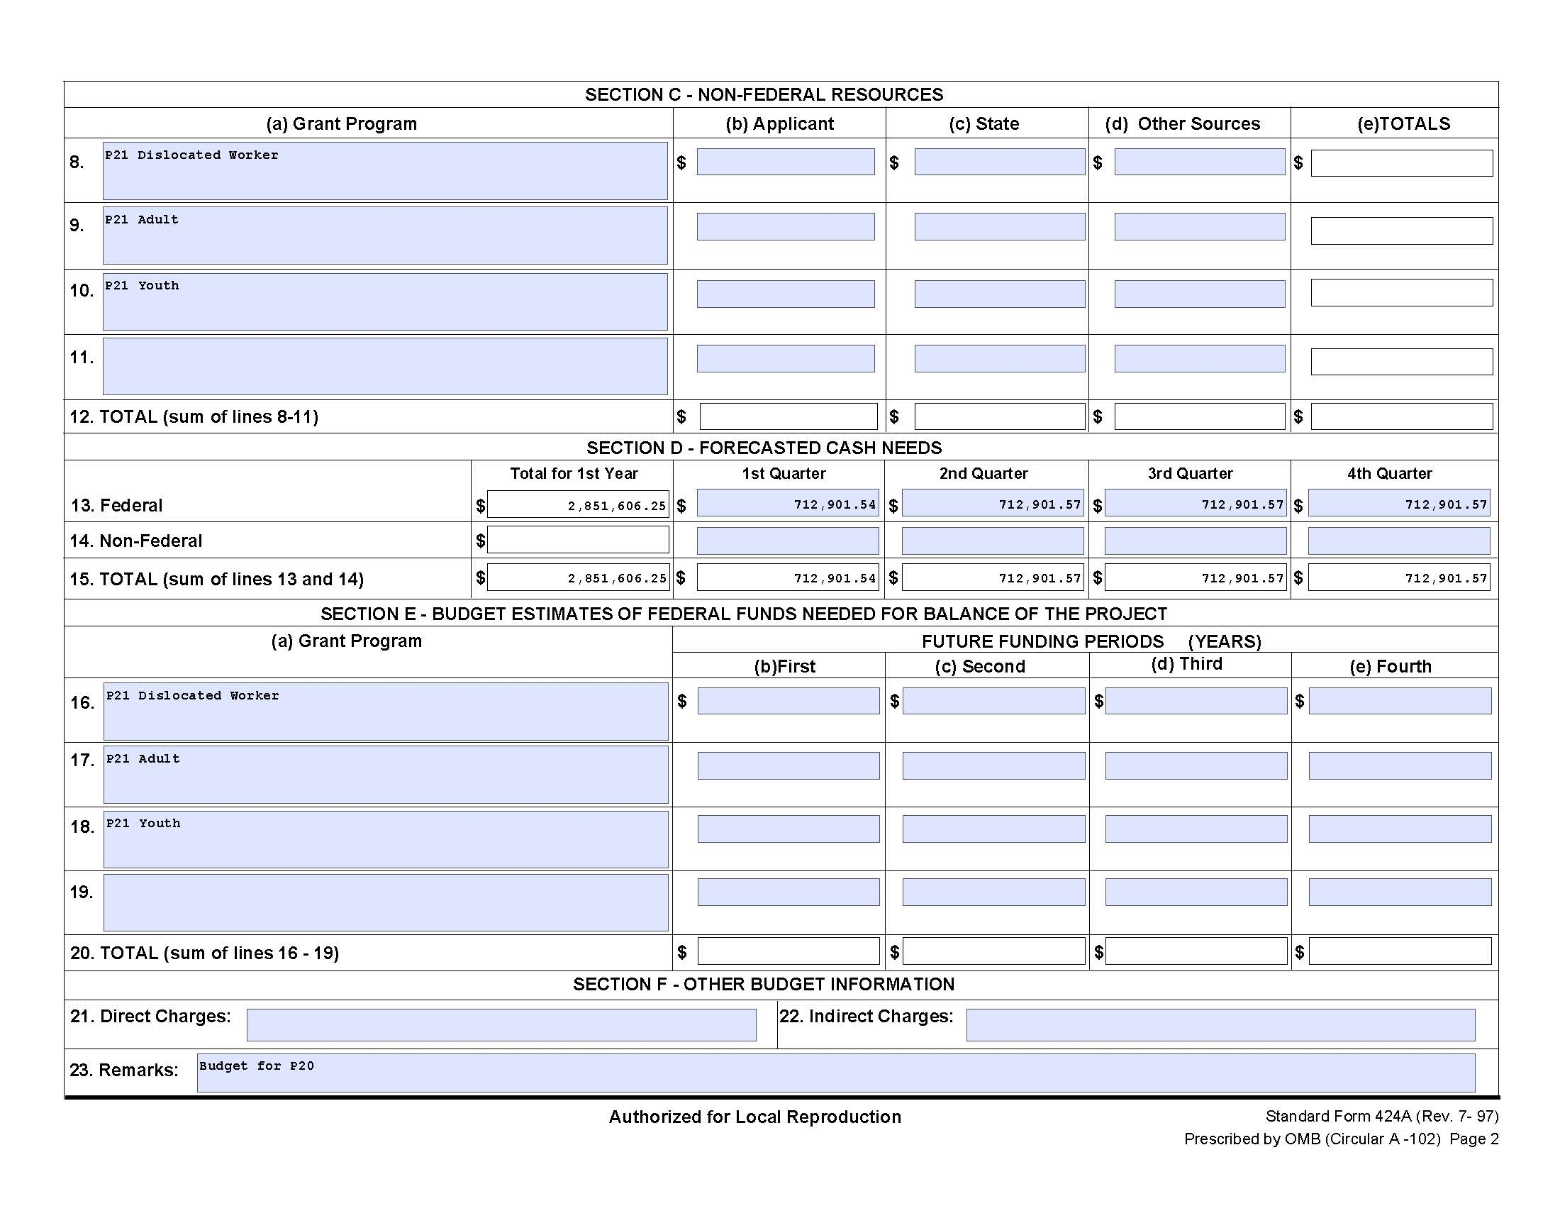

8b. As WIOA Title I formula allocations continue to decline, how does your LWDB leverage partner resources (funding, other) to help further sustain WIOA programs and services to job seekers and employers?
The East Tennessee Local Workforce Development Board advocates co-enrollment with all partners of the service delivery network. This braiding of funds reduces the fiscal strain on Title I formula allocations. Strong community partnerships and recognition of the resources available lessens the strain of all program/partner funds. All partners in the service delivery network are aware of and utilize the Tennessee Disability Pathfinder, http://www.tnpathfinder.org to determine other available resources.

8c. Is your LWDB considering a request for statewide or rapid response funds to support innovative initiatives? If so, what activities will your LWDB plan to support utilizing statewide or rapid response funds?
ETLWDB requested Lay-off Aversion Rapid Response/Incumbent Worker Grant funding for 57,455.00. Six businesses will avoid layoffs through Incumbent Worker Training of current employees with new skills, resulting in pay increases and sustainability of the employers receiving the funds.

8d. Has your local area applied for and/or received any other grants that have provided additional resources? If not, does your local area plan to apply for additional resources to support regional activities?
East eagerly pursues alternative/additional sources of funding. East requested 35,000.00, to serve 10 justice-involved individuals by providing training in connection with TLD Logistics to obtain a Class “A” Commercial Driver's License. The program is unique in that individuals, who complete training, and obtain their Class A CDL license are hired with an existing employer partner. Funding will underwrite the purchase of clothing, testing, licensing, vision correction, and pay partial housing, (sponsored by a faith-based community organization) for individuals recently released from the Morgan County Correctional facility. East, through its parent organization, ETHRA, has applied for a TANF Opportunity Planning Grant. East was awarded one of the 100,000.00 grants for the planning period ending in March 2022. Upon implementation, if successfully awarded, the service delivery structure provides for co-enrollment and braiding of funds between applicable partners within the AJC system.

