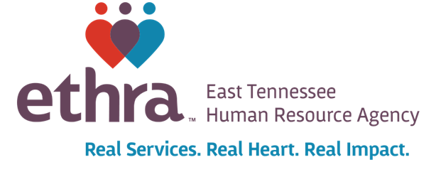

Title VI and Equal Opportunity Assurance

East Tennessee Human Resource Agency, Inc. (ETHRA) assures that no person shall on the grounds of race, color, national origin, or sex, as provided by Title VI of the Civil Rights Act of 1964 and as amended, and the Civil Rights Restoration Act of 1987 (P.I. 100.259) be excluded from participation in, be denied the benefits of, or be otherwise subjected to discrimination under any program or activity receiving federal financial assistance.

ETHRA is an equal opportunity employer/service provider. Any staff member can be of assistance if a special accommodation to fully participate in an ETHRA program is needed.

ETHRA ensures no person shall be excluded from participation in, or denied the benefit of, or subjected to discrimination under any program on the grounds of race, color, sex, age, sex, disability, national origin, family status, political affiliation or belief, citizenship or status of a lawfully admitted immigrant authorized to work in the United States, sexual orientation, gender identity, or any category protected by the state or federal government.

ETHRA further assures every effort will be made to ensure nondiscrimination in all of its programs and activities, whether those programs or activities are federally funded or not.

In the event ETHRA distributes Federal Assistance to a consultant, contractor or subcontractor and other participants, ETHRA will include Title VI language in all written agreements and will monitor the consultant, contractor or sub-contractor and other participants for compliance. The ETHRA Title VI Coordinator is responsible for initiating and monitoring Title VI activities, preparing required reports and other responsibilities as required by 23 CFR 200 and 49 CFR 21.

As required by the contractual agreement, ETHRA will comply with the applicable laws and regulations relative to nondiscrimination in federally or state assisted programs.

For more information, please contact ETHRA’s Title VI/ Equal Opportunity Officer, Steve Bandy:
sbandy@ethra.org, (865) 691-2551, extension 4262, or TTY 1-800-848-0298

